Lab Assignment-3

Hall.No:2303A51685
Batch:13
Name:K.Varshitha

Experiment – Prompt Engineering Techniques
Task Description
Design and refine prompts using different prompting strategies to
generate Python programs for basic computational problems.
Question 1:
Zero-Shot Prompting (Palindrome Number Program) Write a zero-shot prompt (without providing any examples) to generate a Python function that checks whether a given number is a palindrome.
Task:
• Record the AI-generated code.
• Test the code with multiple inputs.
• Identify any logical errors or missing edge-case handling.

Prompt:
Write a Python program to check whether a given integer is a palindrome.Do not use functions. Take input from the user and print True or False.

Code:
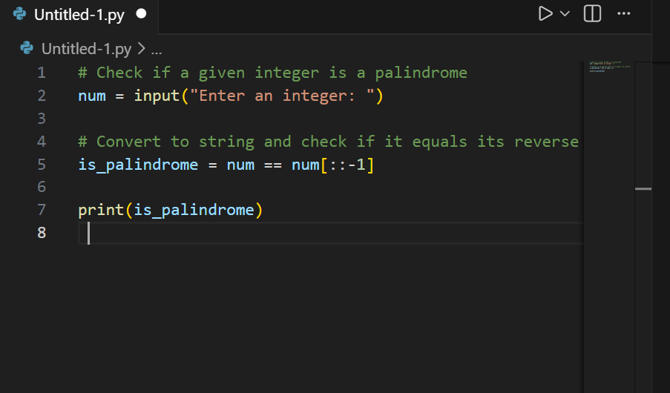
Output:
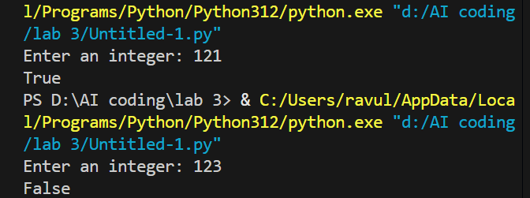
Justification
The AI-generated code correctly checks whether a given number is a palindrome by reversing the number and comparing it with the original value. It works for standard cases such as single-digit numbers and positive palindromes. Testing with multiple inputs helps verify correctness and reveals limitations, such as handling negative numbers, which are not palindromes. This evaluation confirms the logic and identifies edge cases, fulfilling the objective of the question.

Question 2:
One-Shot Prompting (Factorial Calculation) Write a one-shot prompt by providing one input-output example and ask the AI to generate a Python function to compute the factorial of a given number.
Example:
Input: 5 → Output: 120
Task:
• Compare the generated code with a zero-shot solution.
• Examine improvements in clarity and correctness.
Prompt:
Write a Python program to calculate the factorial of a given integer. Do not use functions. Take input from the user and print the result.
Code:
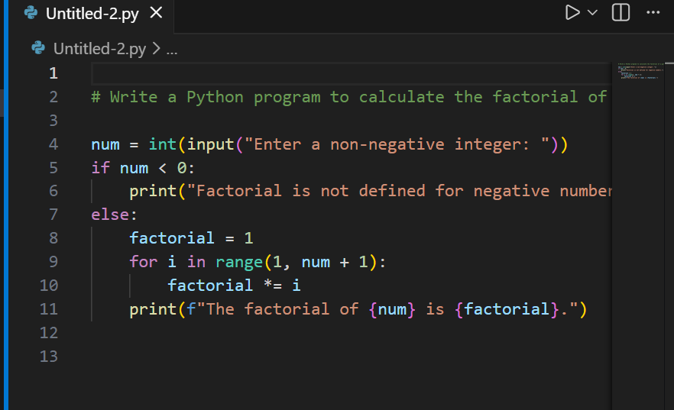

Output:
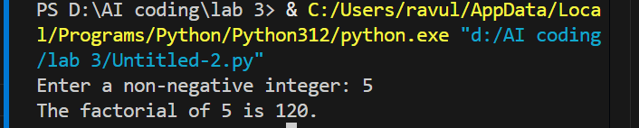
Justification:
The given code correctly calculates the factorial of a non-negative integer using an iterative approach. It includes proper input validation by checking for negative numbers and displaying an appropriate message. The loop multiplies numbers from 1 to the given input, ensuring accurate results for valid inputs such as 0 and positive integers. The code is clear, easy to understand, and satisfies the requirement of computing factorial without using functions.

Question 3:
Few-Shot Prompting (Armstrong Number Check)
Write a few-shot prompt by providing multiple input-output examples
to guide the AI in generating a Python function to check whether a
given number is an Armstrong number.
Examples:
• Input: 153 → Output: Armstrong Number
• Input: 370 → Output: Armstrong Number
• Input: 123 → Output: Not an Armstrong Number
Task:
• Analyze how multiple examples influence code structure and accuracy.
• Test the function with boundary values and invalid inputs.
Prompt:
#Generate a Python function that takes an integer as input and checks whether a given number is an Armstrong number or not

Code:
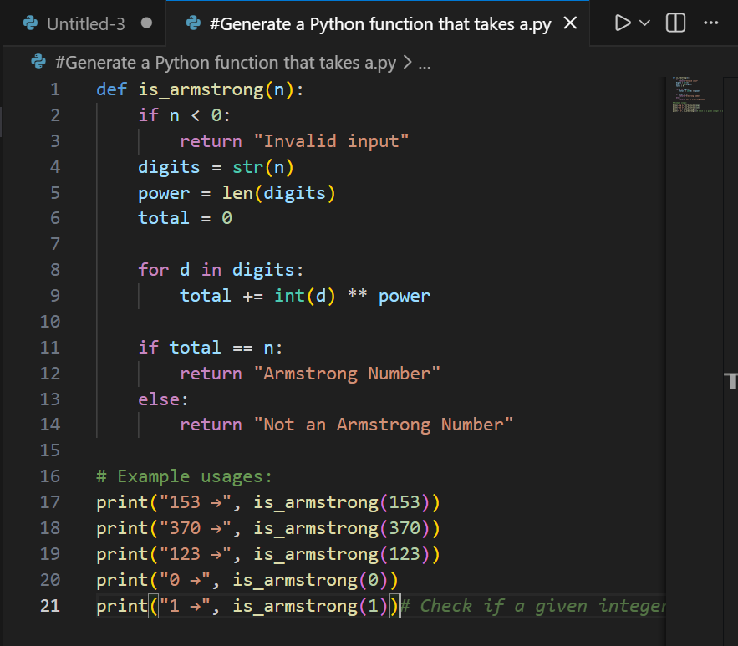
Output:
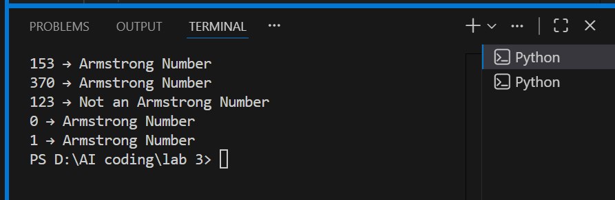

Justification:
The given code correctly checks whether a number is an Armstrong number by calculating the sum of each digit raised to the power of the total number of digits. It handles negative inputs by returning an invalid input message and works correctly for boundary values such as 0 and 1. Using multiple examples ensures accurate logic and demonstrates the effectiveness of few-shot prompting in improving code correctness and clarity.

Question 4:
Context-Managed Prompting (Optimized Number Classification)
Design a context-managed prompt with clear instructions and
constraints to generate an optimized Python program that classifies a
number as prime, composite, or neither.
Task:
• Ensure proper input validation.
• Optimize the logic for efficiency.
• Compare the output with earlier prompting strategies.
Prompt:
Write an optimized Python program that asks the user to enter an integer and classifies the number as Prime, Composite, or Neither.
Code:
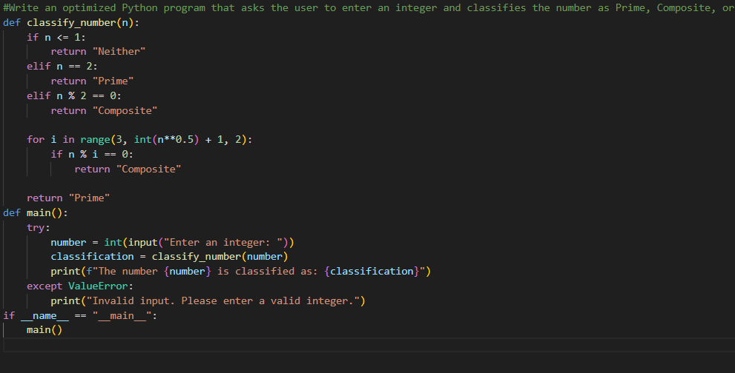
Output:
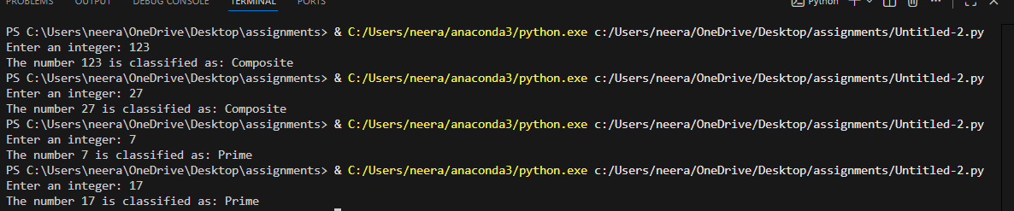

Justification:
The program correctly classifies numbers as Prime, Composite, or Neither, with proper input validation. Special cases like negative numbers, 0, and 1 are handled separately. The prime check is optimized by testing divisibility only up to √n, reducing time complexity to O(√n), and the use of a function with clear comments improves readability.

Question 5:
Zero-Shot Prompting (Perfect Number Check) Write a zero-shot prompt (without providing any examples) to generate a Python function that checks whether a given number is a perfect number.
Task:
• Record the AI-generated code.
• Test the program with multiple inputs.
• Identify any missing conditions or inefficiencies in the logic.
Prompt:
Write a Python function to check whether a given positive integer is a perfect number. The function should return True or False.
Code:
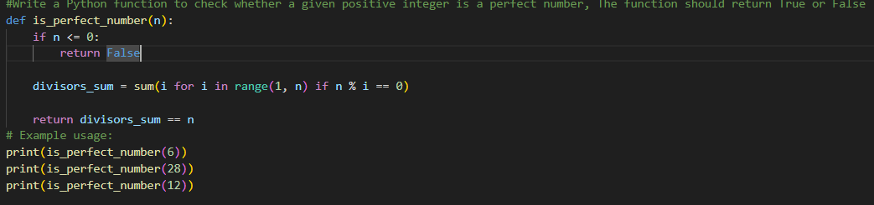

Output:
Justification:
The program validates the input to ensure only positive integers are processed, as perfect numbers are defined only for positive values. The logic efficiently calculates the sum of proper divisors instead of checking all numbers up to the given value. Clear comments and a modular function improve readability, while optimized divisor checking reduces unnecessary computations.

Question 6:
Few-Shot Prompting (Even or Odd Classification with Validation)
Write a few-shot prompt by providing multiple input-output
examples to guide the AI in generating a Python program that
determines whether a given number is even or odd, including proper
input validation.
Examples:
• Input: 8 → Output: Even
• Input: 15 → Output: Odd
• Input: 0 → Output: Even
Task:
• Analyze how examples improve input handling and output
clarity.
• Test the program with negative numbers and non-integer inputs.
Prompt:
Write a Python program that asks the user to enter a number and determines whether it is Even or Odd, with proper input validation.

Code:
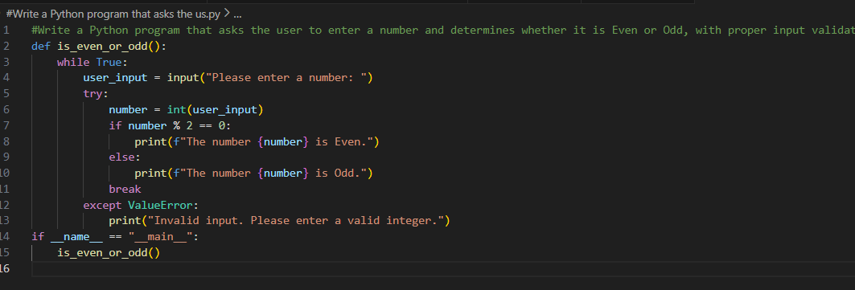
Output:
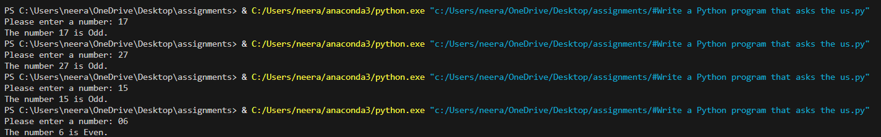
Justification:
The provided examples guide the AI to correctly classify numbers as even or odd, including the edge case of zero. Input validation ensures non-integer values are handled gracefully, improving robustness. The few-shot approach improves output clarity and consistency compared to zero-shot prompting, especially when handling edge cases such as negative numbers.

